Project Design Phase-II
Data Flow Diagram & User Stories

Date | JUNE 2026
Team ID
Project Name | Heritage Treasures: An In-Depth Analysis of UNESCO World Heritage Sites in Tableau
Maximum Marks | 4 Marks

Data Flow Diagrams:
A Data Flow Diagram (DFD) is a traditional visual representation of the information flows within a system. A neat and clear DFD can depict the right amount of the system requirement graphically. It shows how data enters and leaves the system, what changes the information, and where data is stored.
Flow Integration & Dependencies
Sequential Dependencies:
- Data Collection must be completed before Data Preparation
- Data Preparation enables effective Data Visualizations
- Visualizations form the foundation for Dashboard Creation
- Dashboards provide content for Story Development
- Performance Testing runs parallel to all development phases
- Web Integration requires completed dashboards and stories
- Documentation captures the entire development process
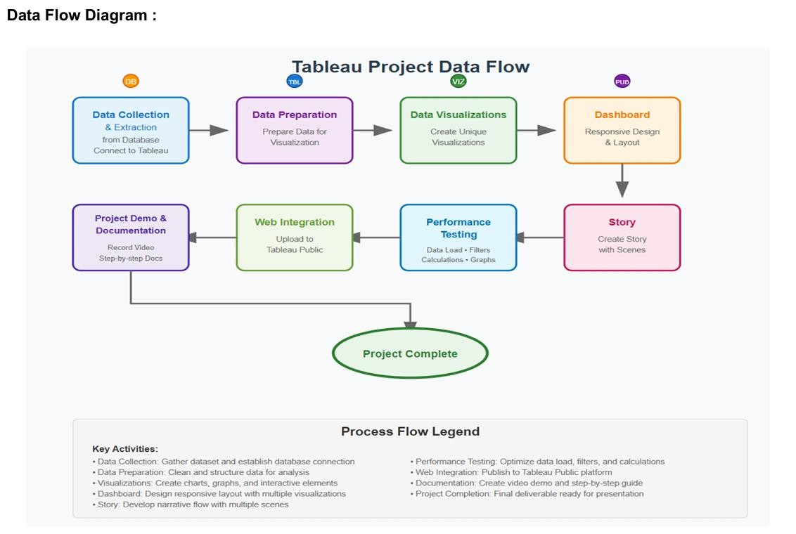

User Stories
Use the below template to list all the user stories for the product.
User Type | Functional  Requirement  (Epic) | User Story  Number | User Story / Task | Acceptance criteria | Priority | Release
Data Analyst | Dashboard  Performance  Optimization | USN-1 | As a Data Analyst, I want dashboards to load within 10 seconds even for global data, so users can explore without delay. | Dashboard loads under 10s; filters respond under 3s | High | Sprint-1
Project  Stakeholder | Data Overview & Site Summary | USN-2 | As a stakeholder, I want to see total heritage site counts by region and category, so I can understand data coverage. | Display total site count, and percentage by category and region | High | Sprint-1
Cultural  Researcher | Heritage Sites Risk Analysis | USN-3 | As a researcher, I want to view endangered sites and compare their areas and regions, so I can focus on highrisk zones. | Pie chart for Danger status, Top 10 danger sites by area | High | Sprint-1
UNESCO  Planner | Regional Trend Insights | USN-4 | As a planner, I want to see how site inscriptions have changed over decades across regions, so I can assess growth trends. | Line chart with yearwise site count; region filter available | Medium | Sprint-1
Tourism Strategist | Category-wise Analysis | USN-5 | As a tourism strategist, I want to analyze which countries have more natural or cultural sites to plan destination marketing. | Bar chart by category, country filter enabled | Medium | Sprint-2
Policy Maker | Country/Region Comparison | USN-6 | As a policymaker, I want to compare number of heritage sites per country within each region, to assess global representation. | Bubble chart by country within region; tooltip with site count | High | Sprint-2
Conservation Team | Forecasting Insights | USN-7 | As a conservation analyst, I want to forecast future site additions using historical data, to predict UNESCO activity. | Forecast chart using Date_inscribed, with estimate & actual series | High | Sprint-2
User Type | Functional  Requirement  (Epic) | User Story  Number | User Story / Task | Acceptance criteria | Priority | Release
Public User | Interactive  Dashboard  Access | USN-8 | As a public user, I want an integrated, interactive dashboard that is easy to navigate and informative. | Unified dashboard view with filters by region, year, danger | High | Sprint-3

